New Volunteer Application Pack

Thank your interest in applying to be Volunteer with SOS NI.

This Application Pack provides you with all the information you need to decide whether SOS is that right charity for you. If you have any questions at all you can contact the SOS Office on 02890 664505.

If, having read through the information, you would like to proceed with your application please complete the doc. Volunteer Registration Form and email the completed form to our Volunteer Coordinator via caitlin@sosbusni.com OR post it to the address below –

SOS NI
Floors 2 & 3 Lanyon View
East Bridge Street
Belfast
BT1 3PH

Looking forward to working with you.

Kindest regards,

Caitlin McCartney
Volunteer Coordinator

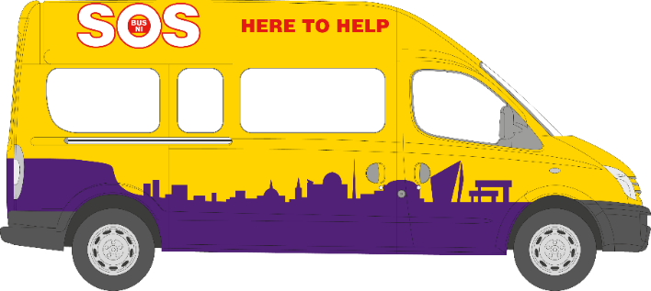

What is SOS Bus NI?

Since 2007, SOS NI has worked in partnership with the emergency services, voluntary organisations, and other statutory organisations every weekend in Belfast. In doing so, we create a safer city for everybody during the busy night-time economy. SOS NI is a recognised Safe Haven at which everybody is warmly received without prejudice or judgement. For those who need emotional and/or physical help, the SOS team provide professional caring and medical support.

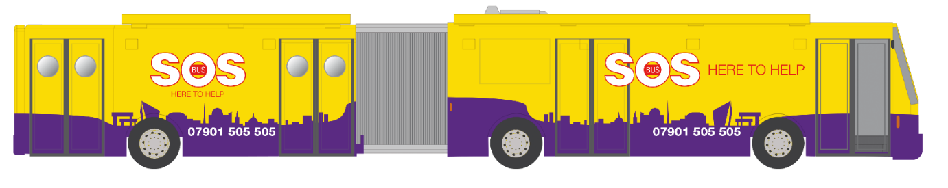

SOS NI boasts a fleet of specially designed vehicles consisting of 2 x Community Buses and 4 x SOS Mini-buses. The Community Buses are parked in Belfast City Centre and are a Safe Space for anyone vulnerable or in need. They are supported by SOS Response Teams, working on-board the SOS Mini-buses. Our third larger vehicle is the SOS Alcohol Recovery Centre, known as the ARC Bus for short. This vehicle is specifically designed to cater to large festivals, such as Belsonic or Vital.

In just over 13 years SOS Volunteers have interacted with over 363,491 people, provided in-depth caring or medical support to 14,590 individuals who have been damaged emotionally or physically on the streets of Belfast and have helped to save many lives.
Our dedicated SOS Volunteers support clients from all different backgrounds who present with a range of different issues which can include -

- Major/ minor accidental injury
- Drunkenness and over indulgence of alcohol and/or drugs
- Homelessness
- Victims of violent crime
- Isolated, lost or separated from friends
- Depression, Suicide or other serious Mental Health issues

SOS Volunteers are provided with all training needed to provide exceptional care to our clients, including Sign-posting Awareness, which trains Volunteers and provides a directory of support services in Northern Ireland that clients can be made aware of and encouraged to contact, in the hopes they can access aftercare.

Since 2007 SOS NI Volunteers have:
Engaged with
363,491
people
Provided in-depth medical and welfare support to
14,162
people
800
people brought Vulnerable to A&E

Volunteer Opportunities

It is only through the wonderful generosity of our 220 trained SOS Volunteers that we can continue to provide our essential services to people in Belfast. SOS NI is a Volunteer led organisation with training and skill based learning at the centre – we fervently believe in building our Volunteers life skills and confidence within the organisation and outside.

No matter which SOS Programme(s) you choose to donate your time to, you can be assured that your contribution will be highly valued and appreciated.

Night-time Services Volunteer

SOS Volunteers who work on our night-time services are asked to donate 4 x hours per month, working as part of an experienced team on one evening shift.

All new Volunteers are immediately placed into a probationary period, during which you will go through the application process that involves several stages –
- attending a New Volunteer Interview
- completing 3-5 buddied shifts on-board the SOS Buses
- completing all compulsory training courses provided by SOS

Once you have complete all stages of your application, you will be involved in a shared review of your performance along with the Volunteer Coordinator. If you pass your review, you will then be asked to join and Core Team and will be presented with an SOS Jacket.

- The minimum age requirement for individuals volunteering on the SOS Bus during a night-time shift is 18 years.

Mini-bus Drivers

SOS Mini-bus Drivers is a popular volunteer role. Driver are required across all SOS Programmes including Night-time Services, Food Programme and our Transport Programme. Hours of volunteering across the Food and Transport Programmes are scheduled both during the day and then evening.

- Requirements to become and SOS Driver -
You must be at least 25 years old
You must have had a full driving license for at least 2 years
You must have less than 3 points on your current license

You do not need any past experience to get involved in the driving of the mini-buses. We are happy to provide any training and pay for driving assessment with a training company.

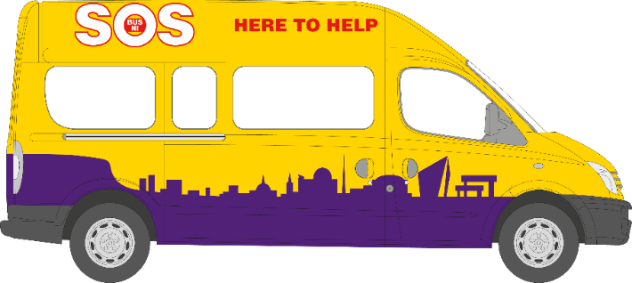

Flasking Team

SOS NI has a small, dedicated team of flaskers who prepare the hot water flasks that are used on the night-time shifts to serve tea, coffee and soup outside the SOS Buses. Each Flasking Team is made up of 1 or 2 Volunteers with shifts usually lasting between 1-2 hours.

This role is perfect for people who want to support SOS NI but who cannot commit to late night shifts.

- There is no age requirement for volunteers in a flasking role. Young people under the age of 18 can volunteer, as long as they are accompanied by an appropriate adult. Why not volunteer with a friend or a younger family member?

Training Opportunities

We acknowledge that it is the outstanding and professional care provided by our Volunteers that has ensured that SOS has become a recognised and trusted organisation in Belfast and beyond. In return for your time and commitment, we wish to invest in your future and are committed to your personal development during your time here at SOS. One way we do this is through Core and Accredited Training courses. All courses are provided free of charge; it is our gift to you.

Core Training

All Volunteers must complete 5 mandatory training courses -

- SOS Induction Evening
- Essential Listening Skills
- Basic Life Support
- JAM Card Training (Online)
- Zero Suicide Training (Online)

Active Volunteers must continue to attend compulsory training courses, which may differ depending on the Volunteer role(s) you are fulfilling –

- Conflict Resolution
- SOS Response Driver Training
- Safe Administration of Naloxone

We are delighted to be able to offer SOS Volunteers further opportunities through optional training to increase their skill sets and personal development through training. Volunteers can look forward to training in the following –

- Safe-guarding Vulnerable Adults & Children
- Drugs Awareness
- PSNI Training (Human Trafficking Unit, Rape Crisis Unit)

Investing in Volunteers Charter

We are delighted to announce that SOS NI has successfully achieved the Investing in Volunteers Quality Standard, recognising our work with volunteers. Investing in Volunteers is the UK quality standard for all organisations involving volunteers that aims to improve the quality of the volunteering experience; to achieve their status demonstrates that organisations value the enormous contribution their volunteers make.

Volunteer Registration Form

Name | D.O.B
Address
 |  | Postcode
Home Tel
Mobile Tel
Email

When choosing an Emergency Contact, please remember that SOS Night-time shifts are conducted late in the evening/early morning and whether your contact will be available to receive a call at this time and whether they will be able to take action.

Emergency Contact Name
Emergency Contact Number
Relationship

Please provide the name and contact details of two Referees (excluding family members) who would be willing to write a reference in regards to whether you are suitable for the type of late night work SOS Bus engages in.

Referee 1
Name
Relationship/Position
Email
Telephone

Referee 2
Name
Relationship/Position
Email
Telephone

Volunteer Questionnaire

How did you hear about SOS Bus NI?

Why would you like to become an SOS Bus NI Volunteer?

Do you have any previous experience of volunteering?

Do you have any special skills or training that you feel would be useful while volunteering with SOS?

Please list any training that you have completed that you feel would be relevant to the consideration of your application.

Please tell us about any health conditions that may impact on your ability to safely perform your volunteer duties.

Volunteer Requirements | Yes / No
Are you over 18 years old?
Are you willing to attend the mandatory volunteer training?

Please indicate by ticking the boxes on the right which volunteer roles you are interested in applying for

Core Night-time Services
Mini-bus Driver
Flasking Team
Community Fundraising

Volunteer Declaration
Can you confirm that there are no reason(s) which exclude you from working with children and vulnerable adults?

Yes No

Would you be willing to submit to an enhanced Access NI check to verify your suitability for the type of work we do?
Yes No

Please read the declaration and sign below –

I certify that the above facts are true to the best of my knowledge and belief.

Signature_________________________________________

Date___________________

